|  |
| --- |
|  |
| Project 3 |
|  |
| Project 3: Data : Group 2 |

**Groep 2**

April 20, 2016

Prepared by: Eljakim Herrewijnen

Project 3

Project 3: Data : Group 2

Inhoud

Introduction: 1

Summary 1

Physical Data model 2

The questions delivered to the Product Owner: 3

The main program for users: 4

The parser for developers: 5

Github repositories: 6

## Introduction:

The goal of both Projects 3 and 4 is to create an informative tool about the city and its neighborhoods, for current/potential citizens of Rotterdam. The application should be multiplatform (at least PC and mobile) and it should contain visualizations/animations on interesting facts related to the city of Rotterdam.

For this project we use the open data database of Rotterdam:

<http://rotterdamopendata.nl/dataset>

We use the safety index of Rotterdam, this contains the crime data of the years: 2006, 2007, 2008, 2009 and 2011 of all the districts in Rotterdam.

<http://rotterdamopendata.nl/dataset/veiligheidsindex-rotterdam-2012>

The complete Database SQL query is delivered with these documents to the Product Owner.

## Summary

To start we made questions to determine what we wanted from the application.

We made a conceptual and physical data model to explain how we want the application to communicate with the database.

For the users we made a GUI based application that shows crime values, depending on the users input.

We made a parser for developers so that they can input queries into the same or an old database. This is delivered with the other products for the product owner but intended for the developers.

## Physical Data model

Conceptual Data Model:

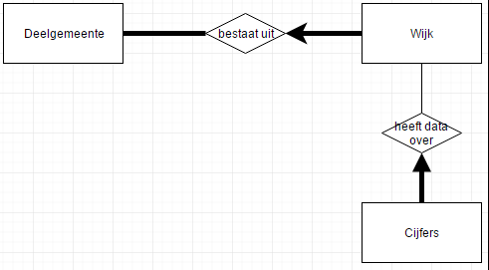

Physical Data model:

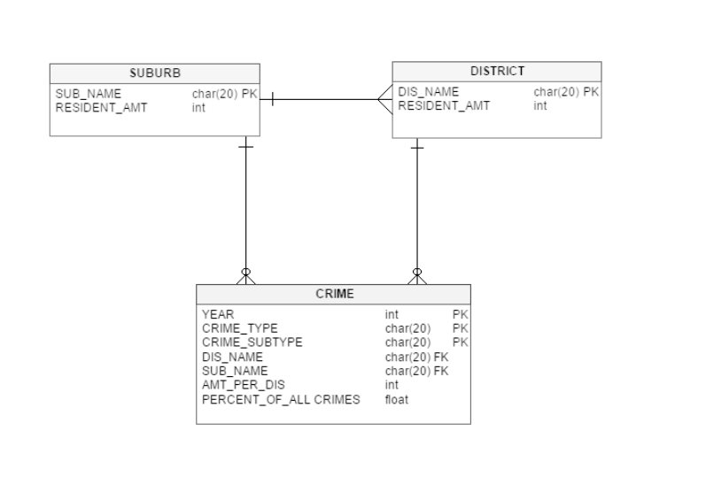

## The questions delivered to the Product Owner:

For this project we use the open data database of Rotterdam:

<http://rotterdamopendata.nl/dataset>

We use the safety index of Rotterdam, this contains the crime data of the years: 2006, 2007, 2008, 2009 and 2011 of all the districts in Rotterdam.

<http://rotterdamopendata.nl/dataset/veiligheidsindex-rotterdam-2012>

**The Questions:**

What is the relative satisfaction with living in each district of Rotterdam?

Which district is relatively most affected by road pollution?

Which district has relatively most nuisance of youth groups?

How many percent of the population in each district is victim of housebreaking?

In which district take the least amount of violent crimes place?

In which district are relatively the least victims of mistreatment?

Which district has relatively the most report of menace?

To which district should I go to have the least risk of bicycle theft?

To which district should I go to have the least risk of car theft?

We want the questions to be answered by using heat maps and graphs. We will use C# and Windows Forms to make these applications.

## The main program for users:

Below you can see a screenshot of the main program for users. This program will display the requested information by the user. The server connection settings are implemented in the code so that the user will not have to deal with them.

In the program you can request to see all boroughs or specified ones. That depends on the users input. The same is for the Area’s.

The program has a heat map, which covers most of the program. The program also has a graph display to show the difference of crime subjects in area’s per year.

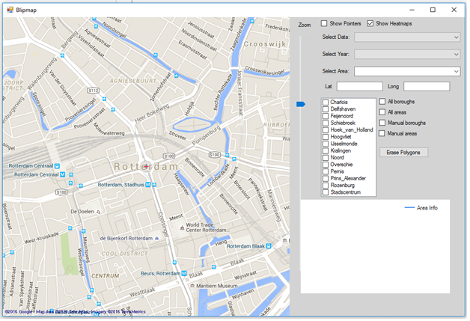

## The parser for developers:

The parser is not intended for users, but since it is delivered with the main program, the users could use it. The parser is made for developers who would like to upload files to a database, even specified ones.

The parser will convert the chosen files to correct SQL queries. If the developer wants to send the queries by hand he could just copy the queries and send them by hand. He could also use the “Send Query” button to send it with the given values for a database connection.

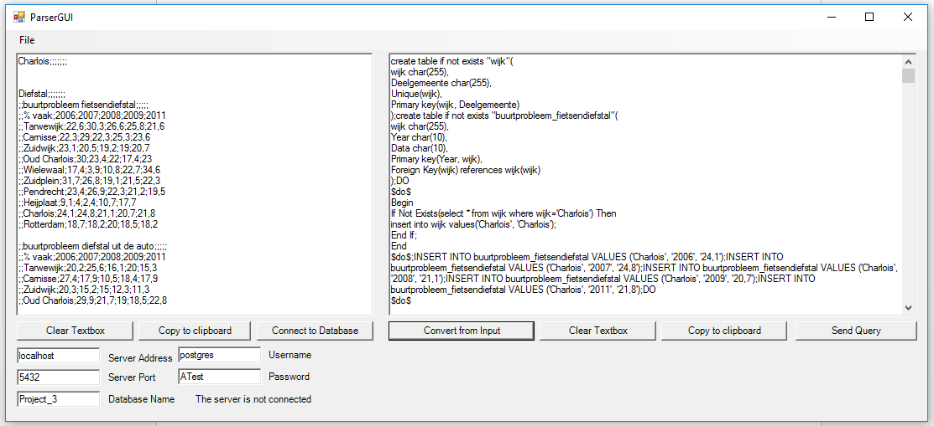

When a Developer wants to test a connection he can click the button: “Connect to database”, and the server will open a connection. If a connection can not be established the application will give an error indicating what is wrong.

When a Developer clicks the button “Send Query” a new connection will be opened with the given connection values displayed in the application and the query will be send. If this is successful the user will be notified, if not, the user will get an error.

## Github repositories:

This is the graph showing the contributions of the contributors of this project. The lines of code is not an explanation of how hard a person worked. For example: The diffirence between the person with the most and the person with the least amount of code is 170.000 lines of code.

Every Person in this project worked equally on this project.

